|  |  |  |
| --- | --- | --- |
| Product Catalogue | Audio connector |  |
| Connector type | 3.5mm headphone jack |  |
| Rated current | - |  |
| Rated voltage | - |  |
| Operating temperature range | - |  |

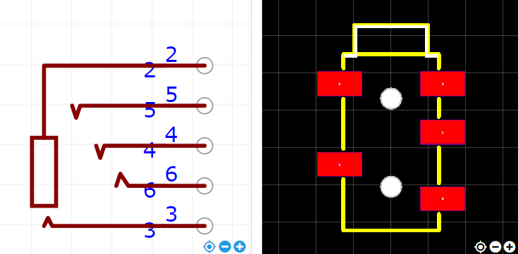

<https://item.szlcsc.com/3300106.html>